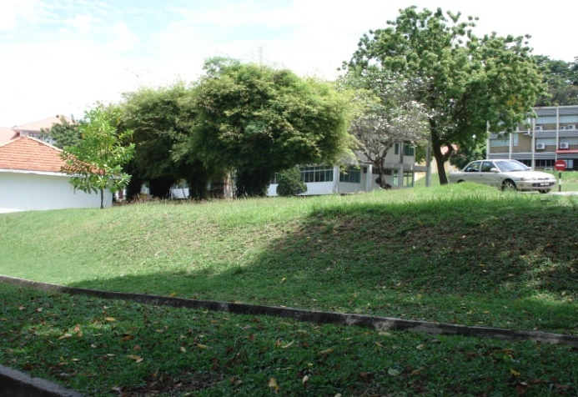
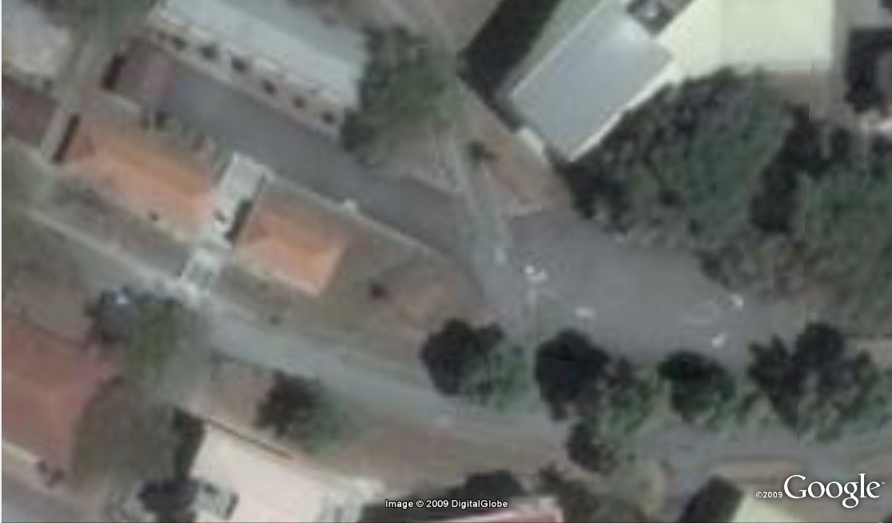
AN URBAN PLAN – CYRSTAL GARDEN

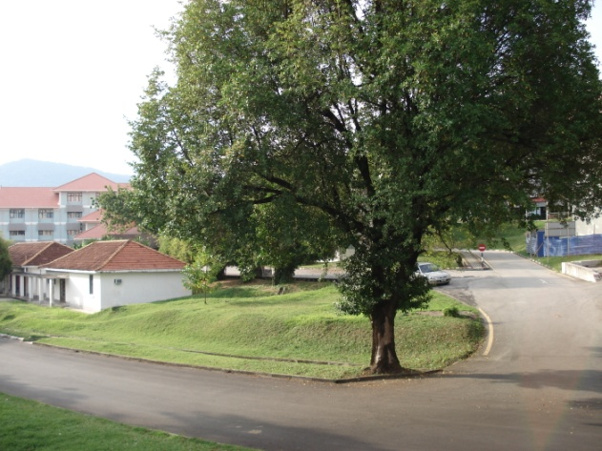
.
The theme garden is located at the centre of the School of HBP, School of Art and School of Education Studies. A fountain is built in the middle of the site. The fountain is the idealized of the combination of a pavilion and waterfall. At the front of the rest stand, there is another little fountain used to symbolize the theme of the garden. Landscaping does its role around the built components as the complement element to enrich the scenery of the site. Since, the land is considered has the steep slope before the garden. So, a stair is built and yet a way is routed besides the stair, to enable the convenience of those disabled people. Plus, two pathway pavilions are constructed at the corner of the fountain, locates in the opposite to each others. We plant the trees to shade the pavilions to reduce the over radiation to the place. Cater to our theme, blue and purple lightings are surrounded the fountain to reflect the crystally structure of the construction.

OLIVA ENDEAVA - LIM BEE KEE (103690), HWONG DICK SON (103676), ANG HUI MING (103650), KHOR SHUIN CHENG (103680), LEE WEI PIN (103687)
SYEVEN TOH TONG JIN (103781)

AN URBAN PLAN – CYRSTAL GARDEN
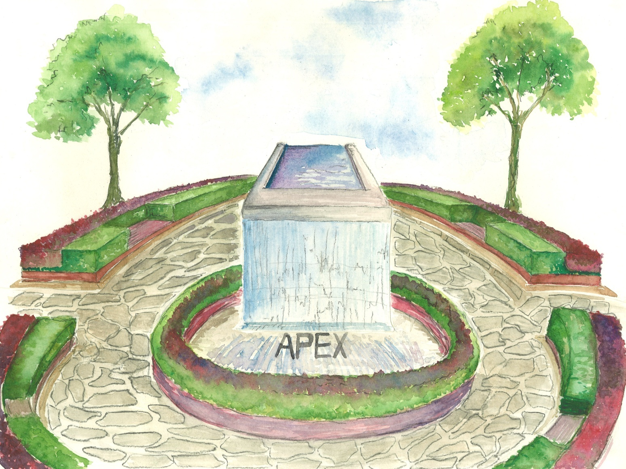
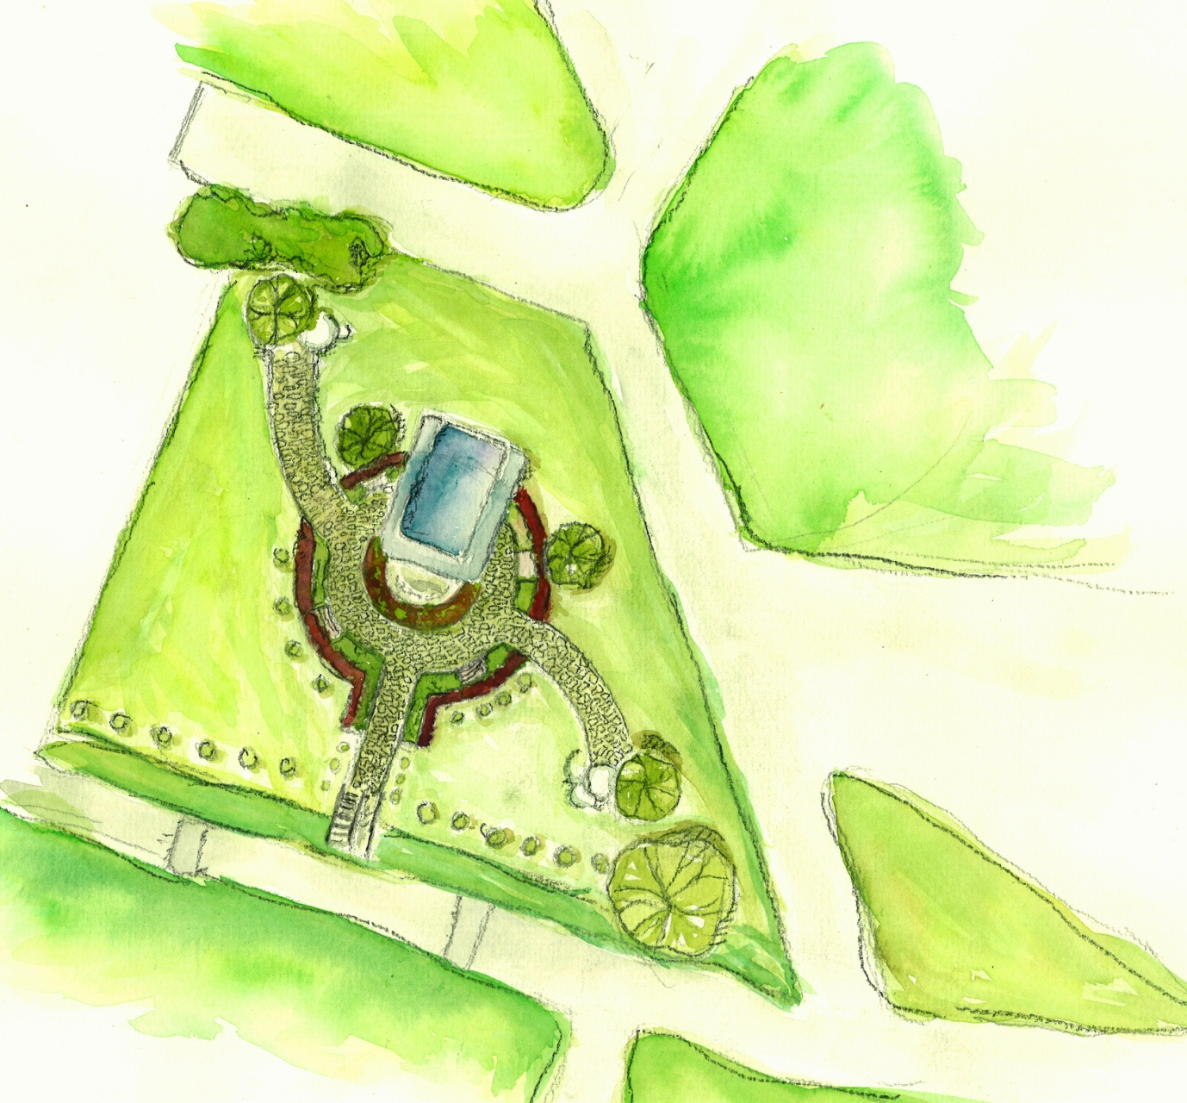
PLAN
PERSPECTIVE

OLIVA ENDEAVA - LIM BEE KEE (103690), HWONG DICK SON (103676), ANG HUI MING (103650), KHOR SHUIN CHENG (103680), LEE WEI PIN (103687)
SYEVEN TOH TONG JIN (103781)

AN URBAN PLAN – CYRSTAL GARDEN
BEFORE AFTER
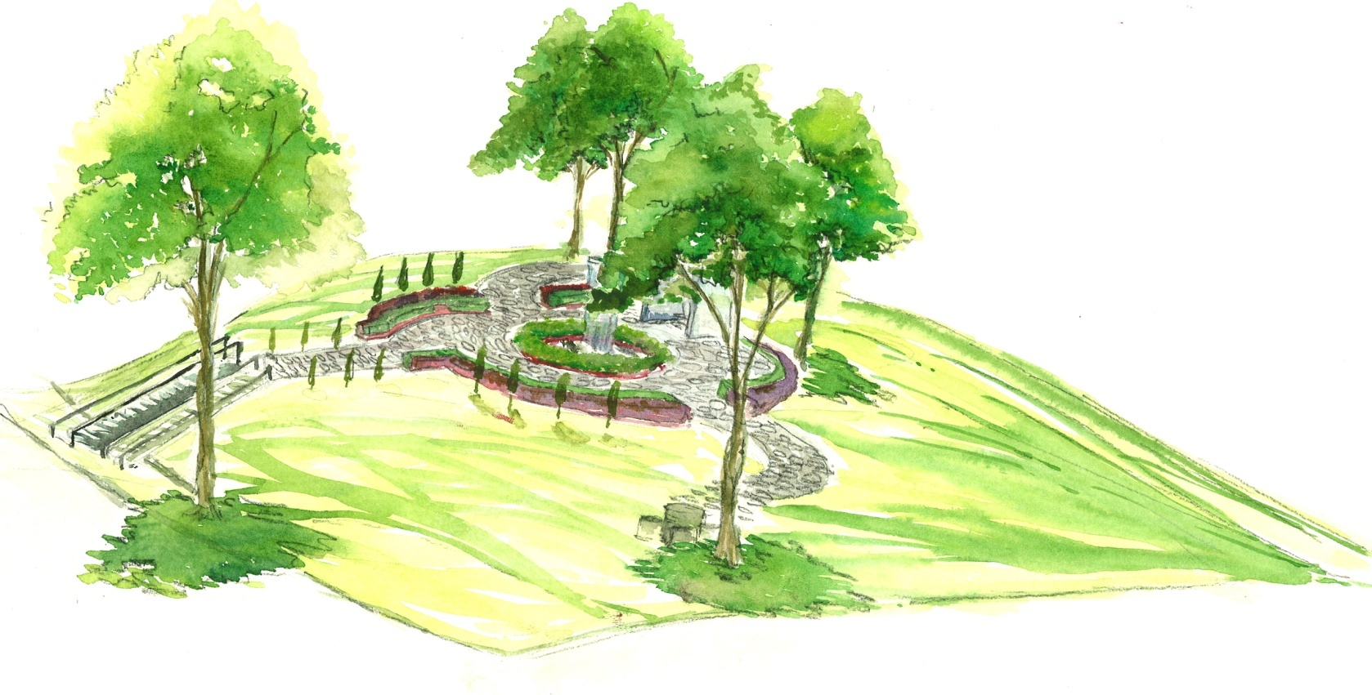
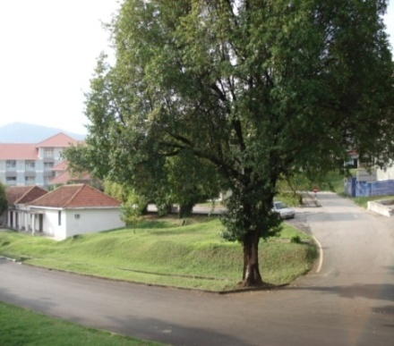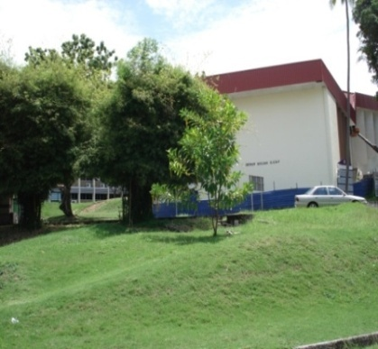

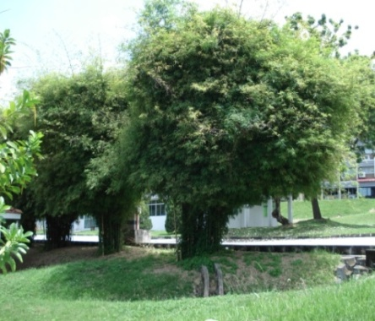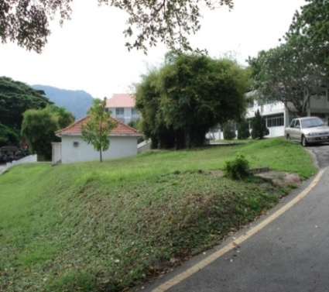

The theme garden locates at the centre of the School of HBP, School of Art and School of Education Studies. Geographically, our site can be analyzed as a low humidity space that incurs the uncontrollable rising of temperature from the bare-exposed to sunlight. Since, the site is situated at the roadsides. This incurs a chronic of pollution to the site and environment, especially the air and sound. It is left to be a useless space and a land where people accumulate the waste at. Moreover, the land has a steep slope, tough for the pass-by to walk on to the space. However, it gives a credit in which there are a lot of plants within the site, which can be maintained to stay. These elements of problem constrict a limit to a construction to be carried in future.

OLIVA ENDEAVA - LIM BEE KEE (103690), HWONG DICK SON (103676), ANG HUI MING (103650), KHOR SHUIN CHENG (103680), LEE WEI PIN (103687)
SYEVEN TOH TONG JIN (103781)
Hence, we propose to have an ideal design using the features of water and green to reduce the influence from the external disturbance.
We are then going to build a fountain at the middle of the site as the main component for the design. The fountain keys the whole control in the ventilation, humidity and air temperature as well. It is designed using the continuous flow of water that source from the pump house that we underlay before the fountain built above a space below. Then the water will pass to a column which is sealed, and flow downwards at the front part as the space is fully occupied. In fact, the downpour can increase the humidity in the empty space within the fountain, a place for people to be held, further cutting down the heat radiation from the sun.
To much furnish the space, we need to build two wayside pavilions as the extra spaces for the students to rest and enclose their relationships during their leisure time. They are shaded with trees to block the direct led sunlight to the users. Besides, pathways are routed around the components built, to be interlinked to each other as shown in the drawing. Plus, the walk paths contribute a place for the students to exercise or relax.
Furthermore, bumpers are strictly legislated around the garden we built. This is purposely to decelerate the car, yet the safety of students is guaranteed. Everything we do planned is to ensure the schools; students and all the people around could enjoy its existence as it much contributes to everyone.

BIODIVERSITY
DEFINITION OF BIODIVERSITY
Biodiversity is a contraction of the phrase "biological diversity". Biology means all the living things found within the ecosystem and diversity means the wide variety of something, Therefore, overall, biodiversity describes is the study of the variety of life forms such as animals, plants ,and other living things within the ecosystem at all levels of biological systems.
TYPE OF BIODIVERSITY
Biodiversity exists at three levels: ecosystems, species, and genes.
An ecosystem is an array of living organisms and the physical and chemical environment with which they interact.
There are many types of ecosystems, ranging from the very large (forests, oceans, etc.) to the relatively small (a single pond can comprise an ecosystem by itself).
The functioning of a given ecosystem is driven by its constituent organisms and is best understood as a cyclical flow of energy and materials.
Depending on its characteristics (area, latitude, diversity of terrain, etc.) an ecosystem may contain many millions of different species or merely a handful.
The species is the yardstick by which the variety of life has traditionally been measured.
To date, roughly 1.7 million species of plants, animals and microorganisms have been discovered and formally described.
This roster of known species represents only a fraction of the total number.
The gaps in our knowledge are easily seen.
At the genetic level, biodiversity can be seen within as well as between species – in the differences between populations and even individuals of the same species.
The almost limitless variability of genes is thus the fundamental basis of biodiversity.
OLIVA ENDEAVA - LIM BEE KEE (103690), HWONG DICK SON (103676), ANG HUI MING (103650), KHOR SHUIN CHENG (103680), LEE WEI PIN (103687)
SYEVEN TOH TONG JIN (103781)

EXAMPLE
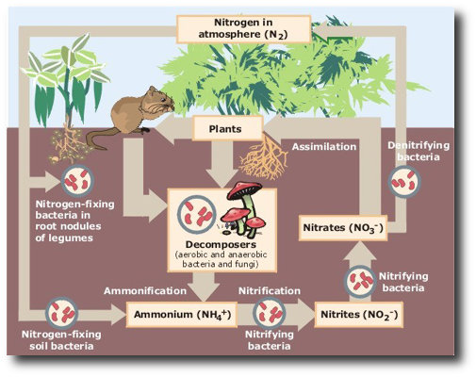
A REVIEW ON BIODIVERSITY
Currently biodiversity encounters a variety of crisis.
Examples of biodiversity crisis
- Threaten our food supplies, opportunities for recreation and tourism, and sources of wood, medicines and energy.
- Interfere with essential ecological functions
- Global atmospheric changes, such as ozone depletion and climate change, only add to the stress.
- Global warming is already changing habitats and the distribution of species.
- Reduces the productivity of ecosystems, thereby shrinking nature's basket of goods and services, from which we constantly draw.
THE MAIN CAUSES OF BIODIVERSITY CRISIS
- Habitat destruction.
- Invasive species
- Pollution
- Over-harvesting
- Climate change:
- Market and economic policy failures
- Social, political and institutional weaknesses
- Lack of knowledge of biodiversity’s importance
THE IMPORTANT OF BIODIVERSITY TO NATURAL ENVIRONMENT
Biodiversity boosts ecosystem productivity where each species, no matter how small, all have an important role to play.
- Activities of microbial and animal species can improve and maintain the soil quality.
- Maintenance of air quality by regulating the composition of the atmosphere.
- Maintenance of water quality whereby Wetland ecosystems absorb and recycle essential nutrients, treat sewage, and cleanse wastes.
- Pest control
- Detoxification and decomposition of wastes by the activities of living things
- Natural pollination and crop production by activities of various animal species
- Plant tissues and other organic materials within land and ocean ecosystems contributing to climate stabilization.
- Prevention and mitigation of natural disasters

A healthy biodiversity offers many natural services
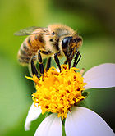
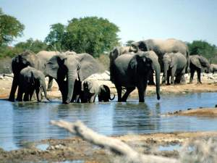

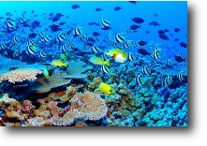
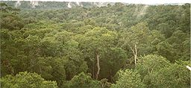
BIODIVERSITY
Tembusu Tree (Fagraea Fragrans sp.)
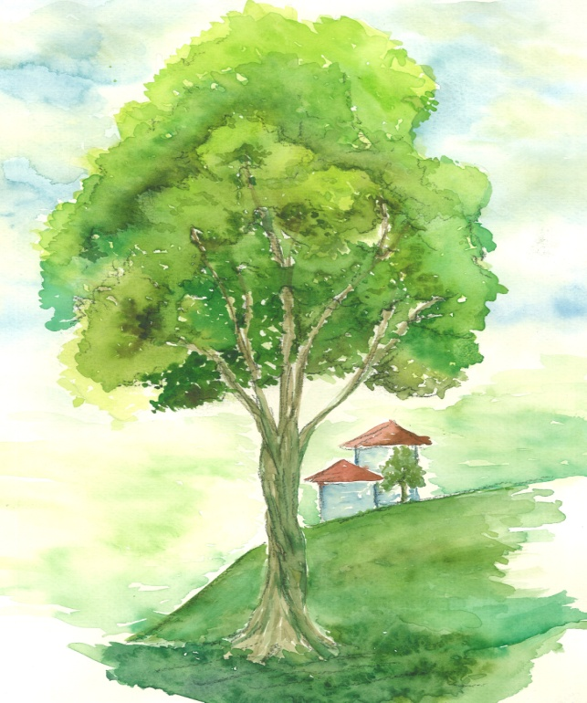
8100 mm
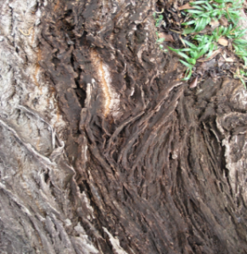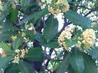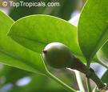
About Tembusu Tree
The tembusu can grow up to 30 m to 40 m tall. Its crown is fairly conical when young, and later grows into a lofty and irregular shape with a few short, horizontal branches from which grow tall and upright branches bearing small, hanging twigs. The trunk has a thick, distinctive dark brown, deeply-fissured bark. The leaves are light green, about 5 cm to 8 cm in length and oval-shaped with protective leaf tips.
OLIVA ENDEAVA - LIM BEE KEE (103690), HWONG DICK SON (103676), ANG HUI MING (103650), KHOR SHUIN CHENG (103680), LEE WEI PIN (103687)
SYEVEN TOH TONG JIN (103781)

2140 mm
Location and brief description of the site
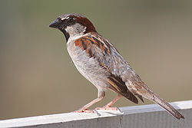
The tree we have chosen is located just in front of our designated theme garden site. It is a huge and years-aged tree. This showing that the site is full of the sufficient supply of nutrients for the plants surround. How to maintain them in a very pretty well condition? The place is a low humidity and increasing high temperature condition, especially during the midday. However, the tree and the other plants showing us a scene of a quite health condition and freshy well. This is due to the condition and type of the soil. The soil is soft type which composed of lot of sand and humus. This enables the roots of the plants can penetrate to much downwards to absorb more water.

The diversified species around the tree
A squirrel is one of many small or medium-sized rodents in the family Sciuridae. In the English-speaking world, squirrel commonly refers to members of this family's genera Sciurus and Tamiasciurus, which are tree squirrels with large bushy tails, indigenous to Asia, the Americas and Europe.

Ants are social insects of the family Formicidae (pronounced /fɔrˈmɪsəˌdiː/), and along with the related wasps and bees, they belong to the order Hymenoptera. Ants evolved from wasp-like ancestors in the mid-Cretaceous period between 110 and 130 million years ago and diversified after the rise of flowering plants.
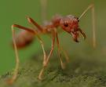

Bees are flying insects closely related to wasps and ants, and are known for their role in pollination and for producing honey and beeswax. Bees are a monophyletic lineage within the superfamily Apoidea, presently classified by the unranked taxon name Anthophila.
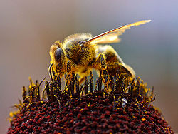

The House sparrow is the number two urban pest birds. They nest in urban structures, eat scraps and have a large breeding capacity is some of their traits. Their legs and toes are favoured for branch perching and their short conical bills are ideal for seed cracking.

